

|  |
| --- |
| **INTERPOLATION**  **Md. Mehedi Hasan, Lecturer @ DIU** |

**Meaning of Interpolation:**

In our daily life we are sometimes confronted with the problem where we become interested in finding some unknown values with help of a given set of observations. For example, if we are find out the population of Bangladesh in 1978 when we know the population of Bangladesh in the year 1971, 1975, 1979, 1984, 1988, 1992 and so on. i,e. the figure of population are available for 1971, 1975, 1979, 1984, 1988, 1992 etc, then the process of finding the population of 1978 is known as interpolation.

**Definition of Interpolation:**

In the mathematical field of numerical analysis,interpolation is a method of constructing new data points within the range of a discrete set of known data points.

Mathematically, let the observations of a function $y=f(x)$ be $f\left(a\right), f\left(a+h\right), f\left(a+2h\right)…………f(a+nh)$ for $x=a, a+h, a+2h,……a+nh$ respectively. Then the method of finding $f(x)$ for $x=α,$ where $α$ lies in the range $a$ and $a+nh$ is known as **interpolation** and if the value of $x=α$ lies outside this range it is called **extrapolation.**

For example, let as suppose we are given the following data.

|  |  |  |  |  |  |  |
| --- | --- | --- | --- | --- | --- | --- |
| $$x=$$ | 0 | 3 | 6 | 9 | 12 | 15 |
| $$f\left(x\right)=$$ | 1 | 2 | 7 | 12 | 17 | 22 |

Then the method of finding $f(10)$ or $f(4)$ with help of the given data will be called **interpolation** and that for $f(27)$ or $f(-2)$ will be known as **extrapolation**.

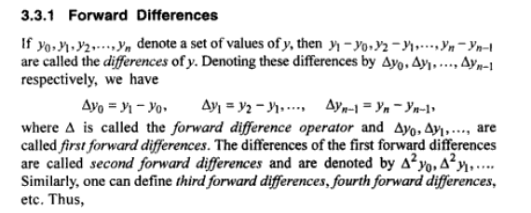

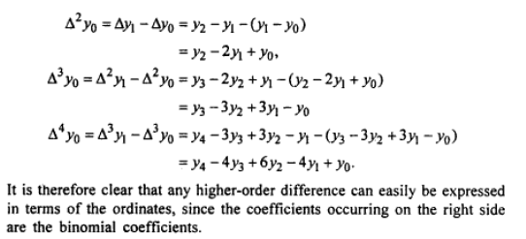

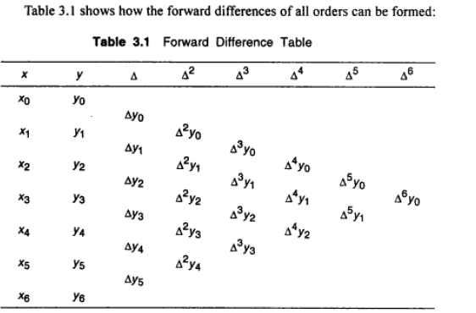

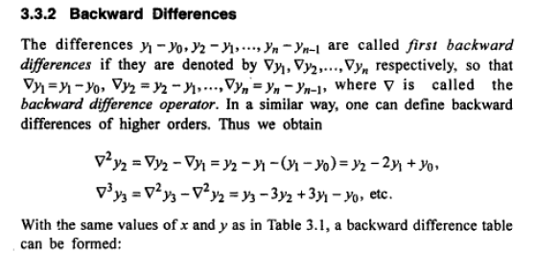

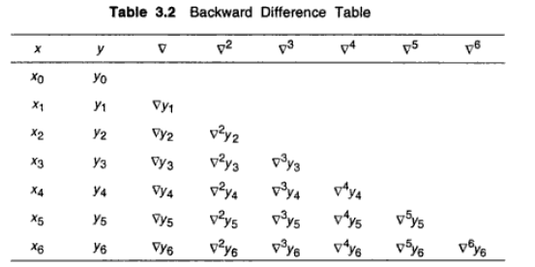

**Interpolation/Extrapolation**

If the difference of $x$ is equal or not for both condition it applicable.

If the difference of $x$ is equal then it applicable.

**Newton’s Interpolation formula**

**Lagrange’s Interpolation formula**

**Newton Forward Interpolation formula**

**Newton Backward Interpolation formula**

**Newton’s Formula For Interpolation:**

**Newton’s Forward Difference:**

If the given data is,

|  |  |  |  |  |  |  |
| --- | --- | --- | --- | --- | --- | --- |
|  |  |  |  |  | ………. |  |
|  |  |  |  |  | ………. |  |

Then the Newton’s forward interpolation formula will be,



Where,  = difference of $x$ which is always equal interval.

**Newton’s Backward Difference:**

If the given data is,

|  |  |  |  |  |  |  |
| --- | --- | --- | --- | --- | --- | --- |
|  |  |  |  |  | ………. |  |
|  |  |  |  |  | ………. |  |

Then the Newton’s backward interpolation formula will be,



Where,  = difference of $x$ which is always equal interval.

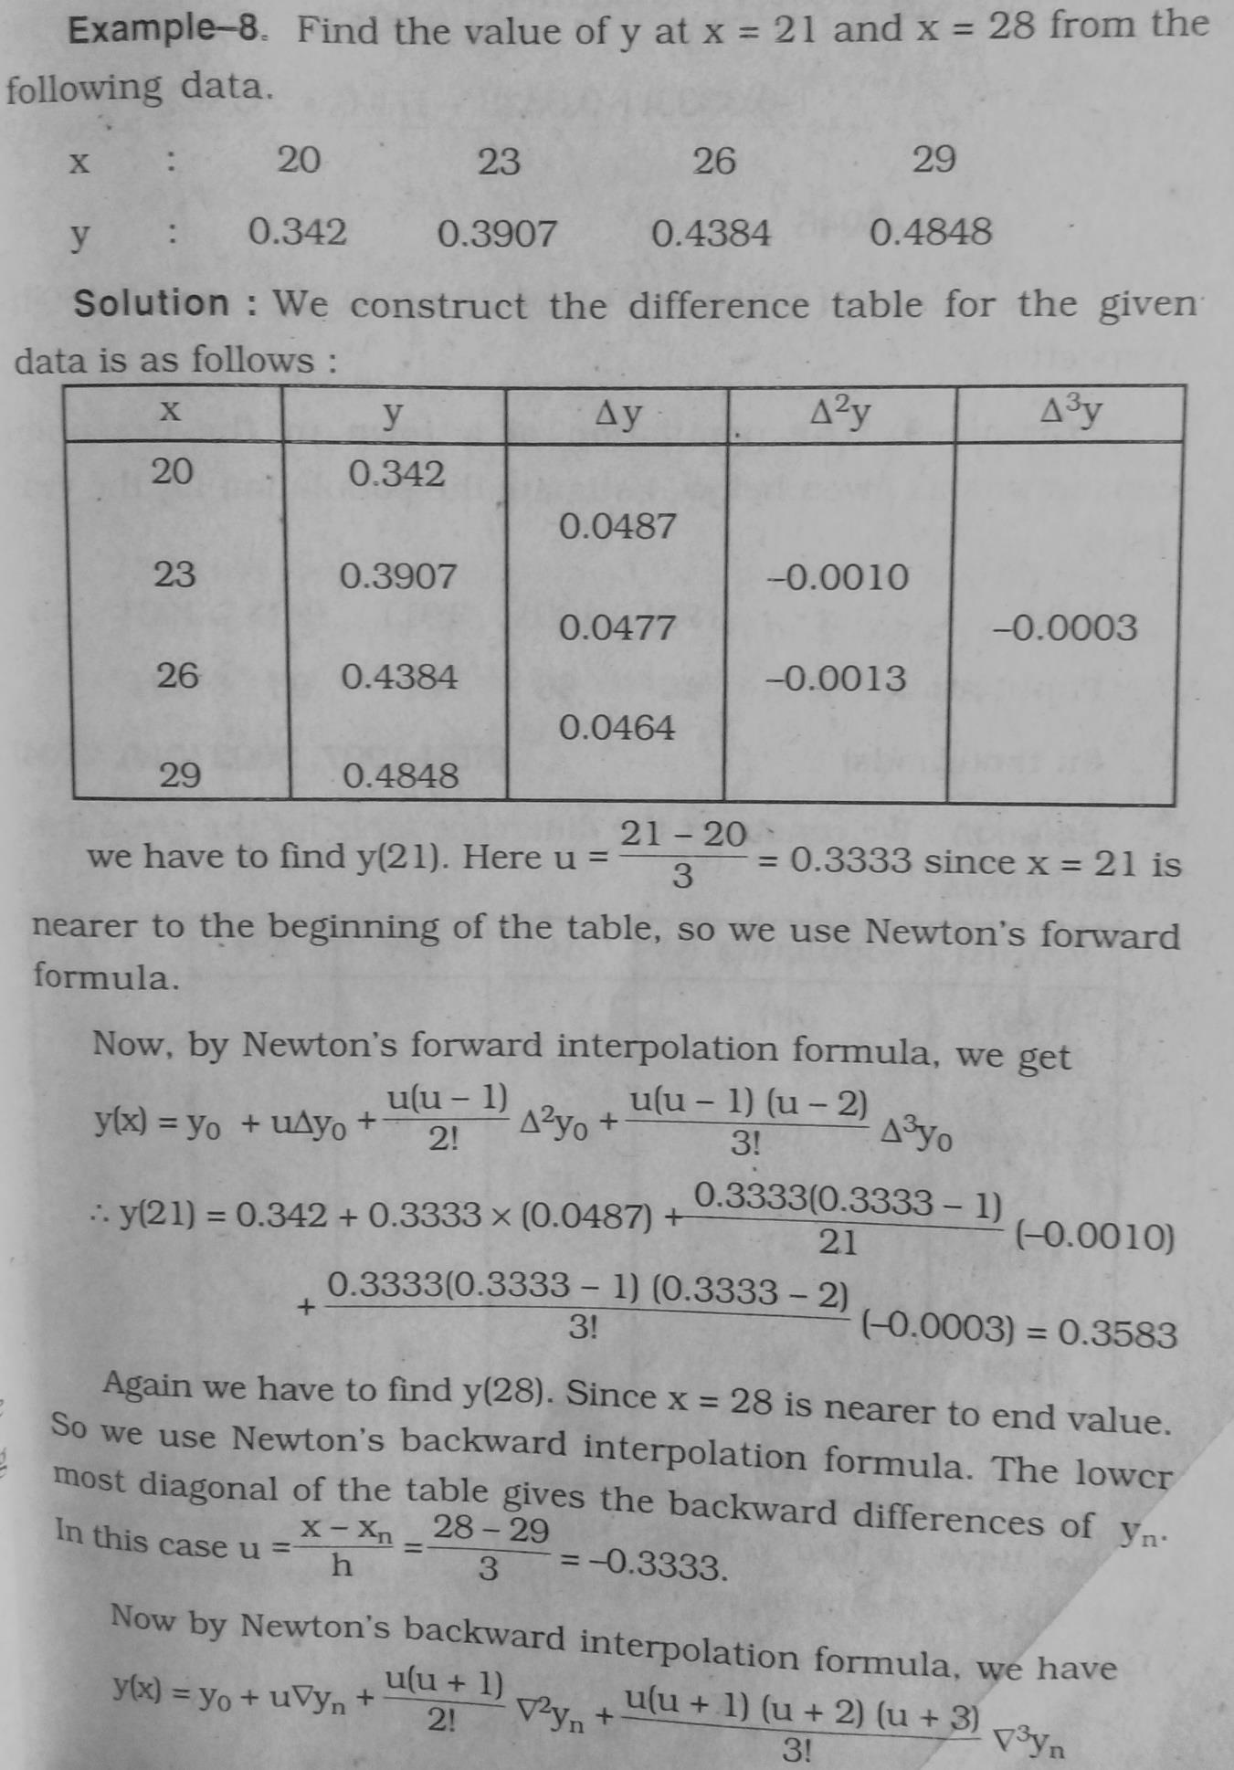

**Problem Solving:**

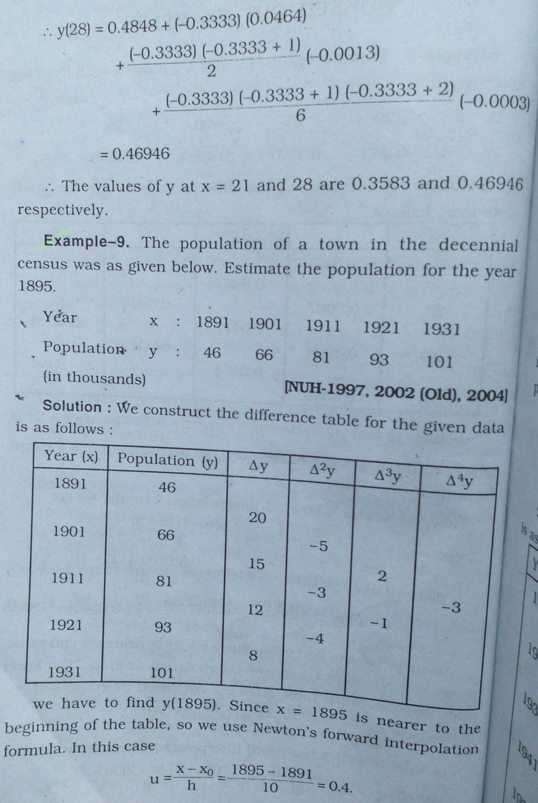

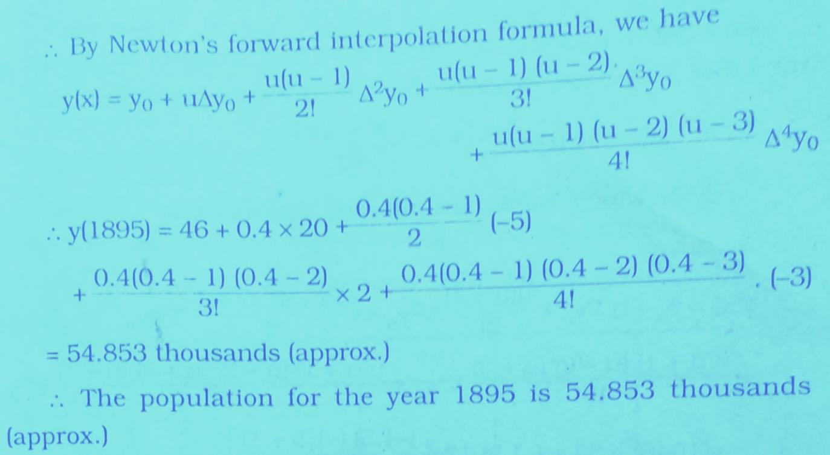

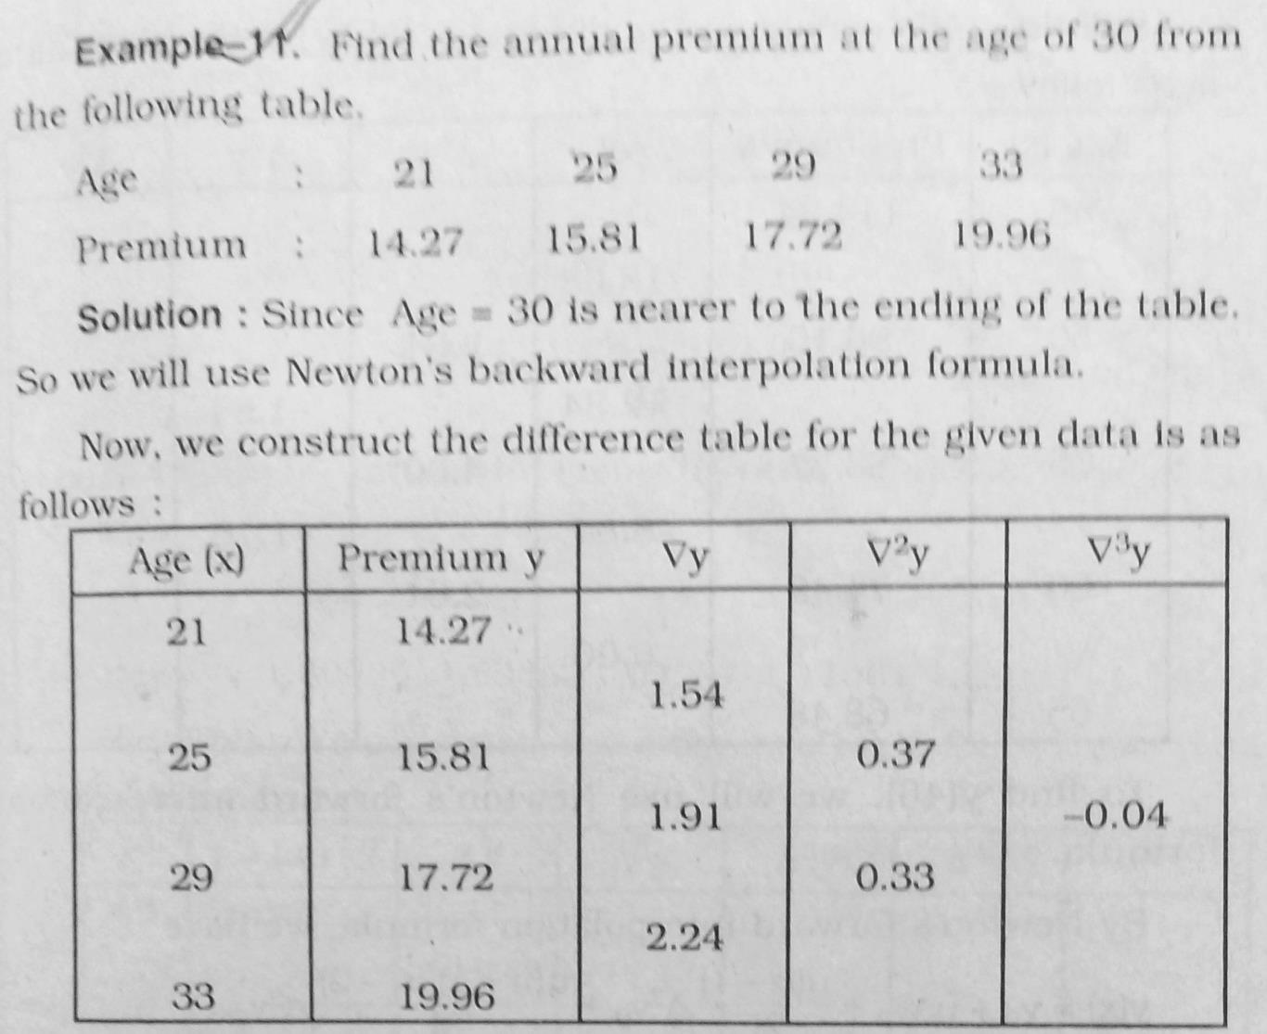

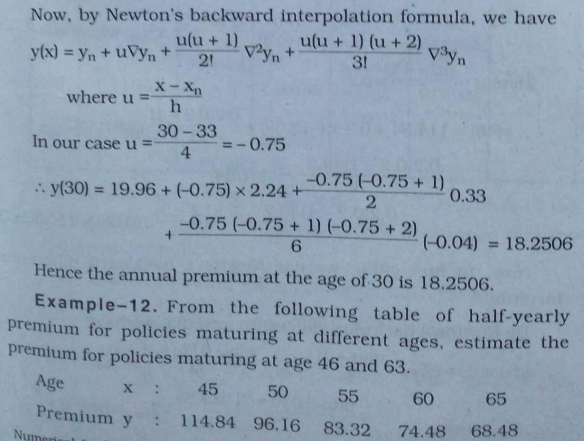

**Answer:** Try yourself.

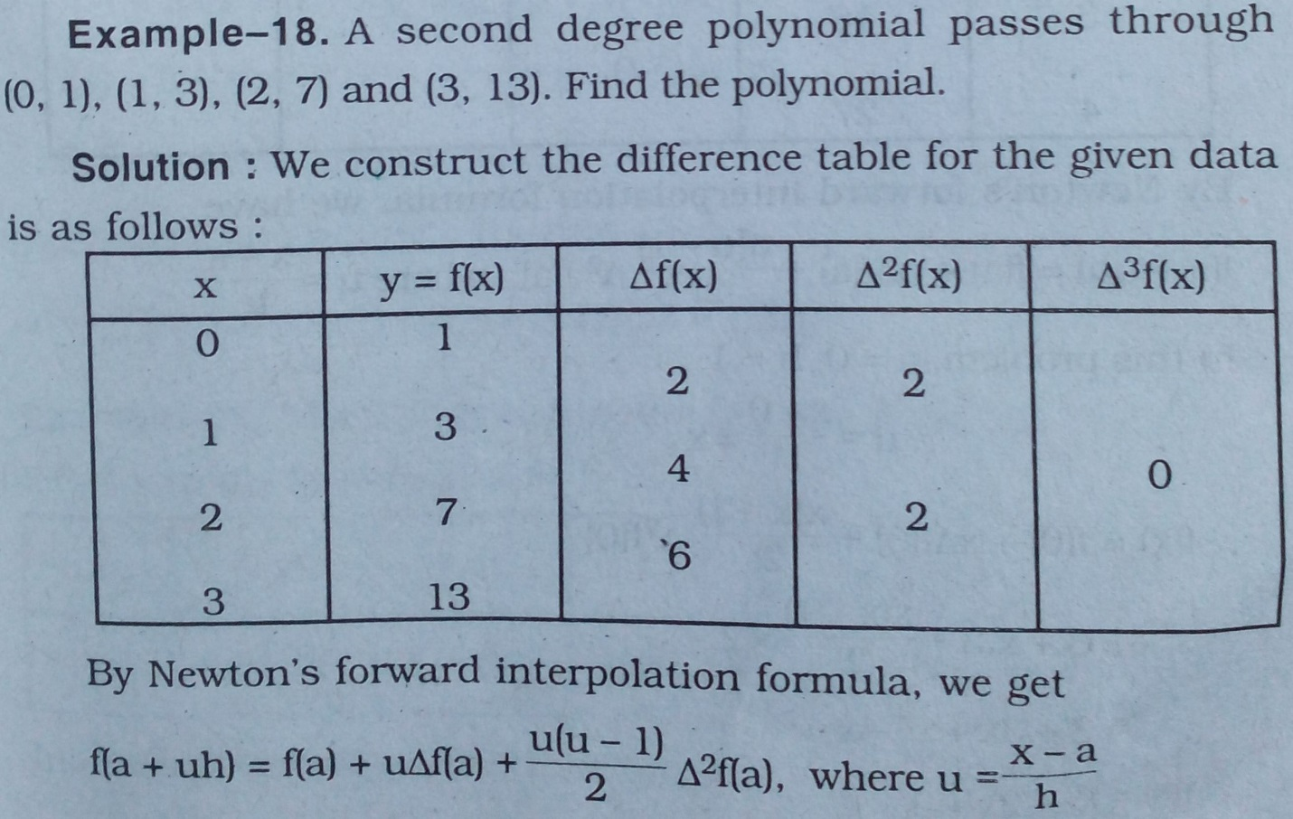

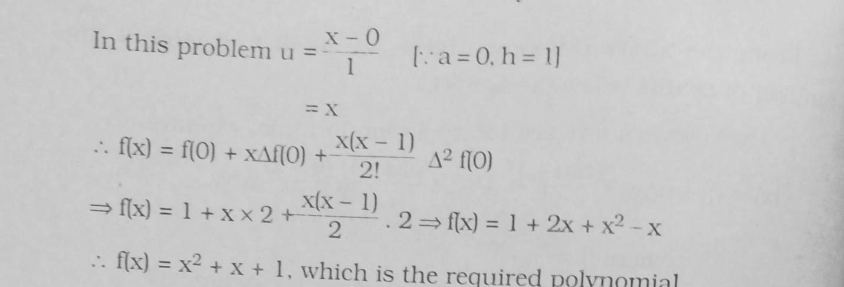

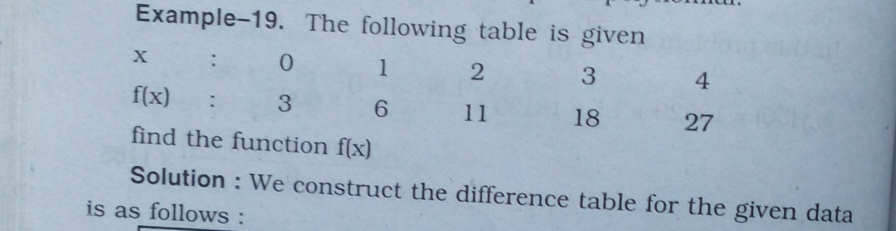

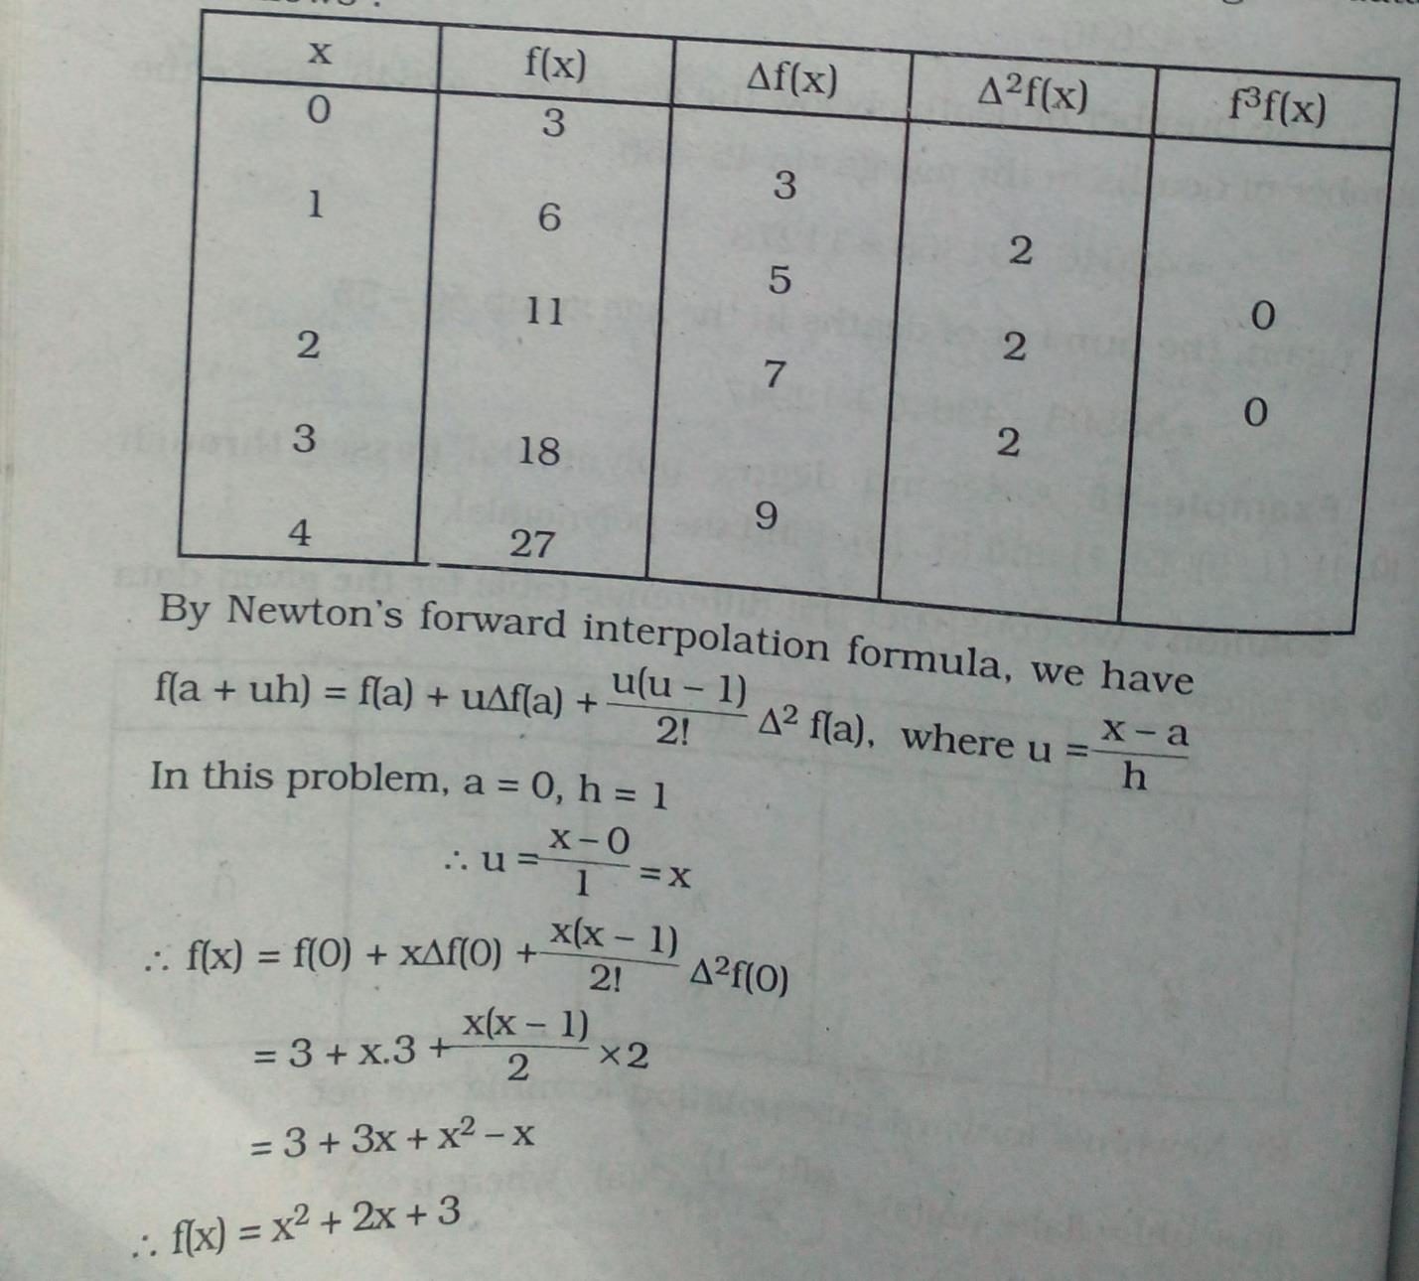

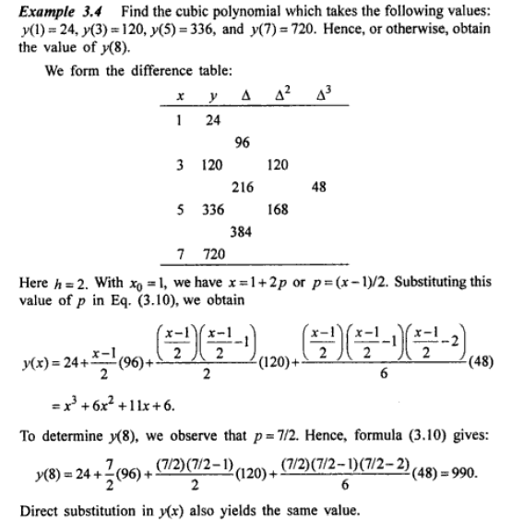

**For Practice:**

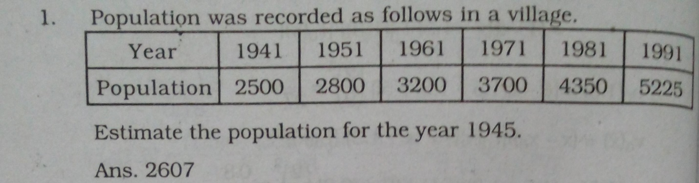

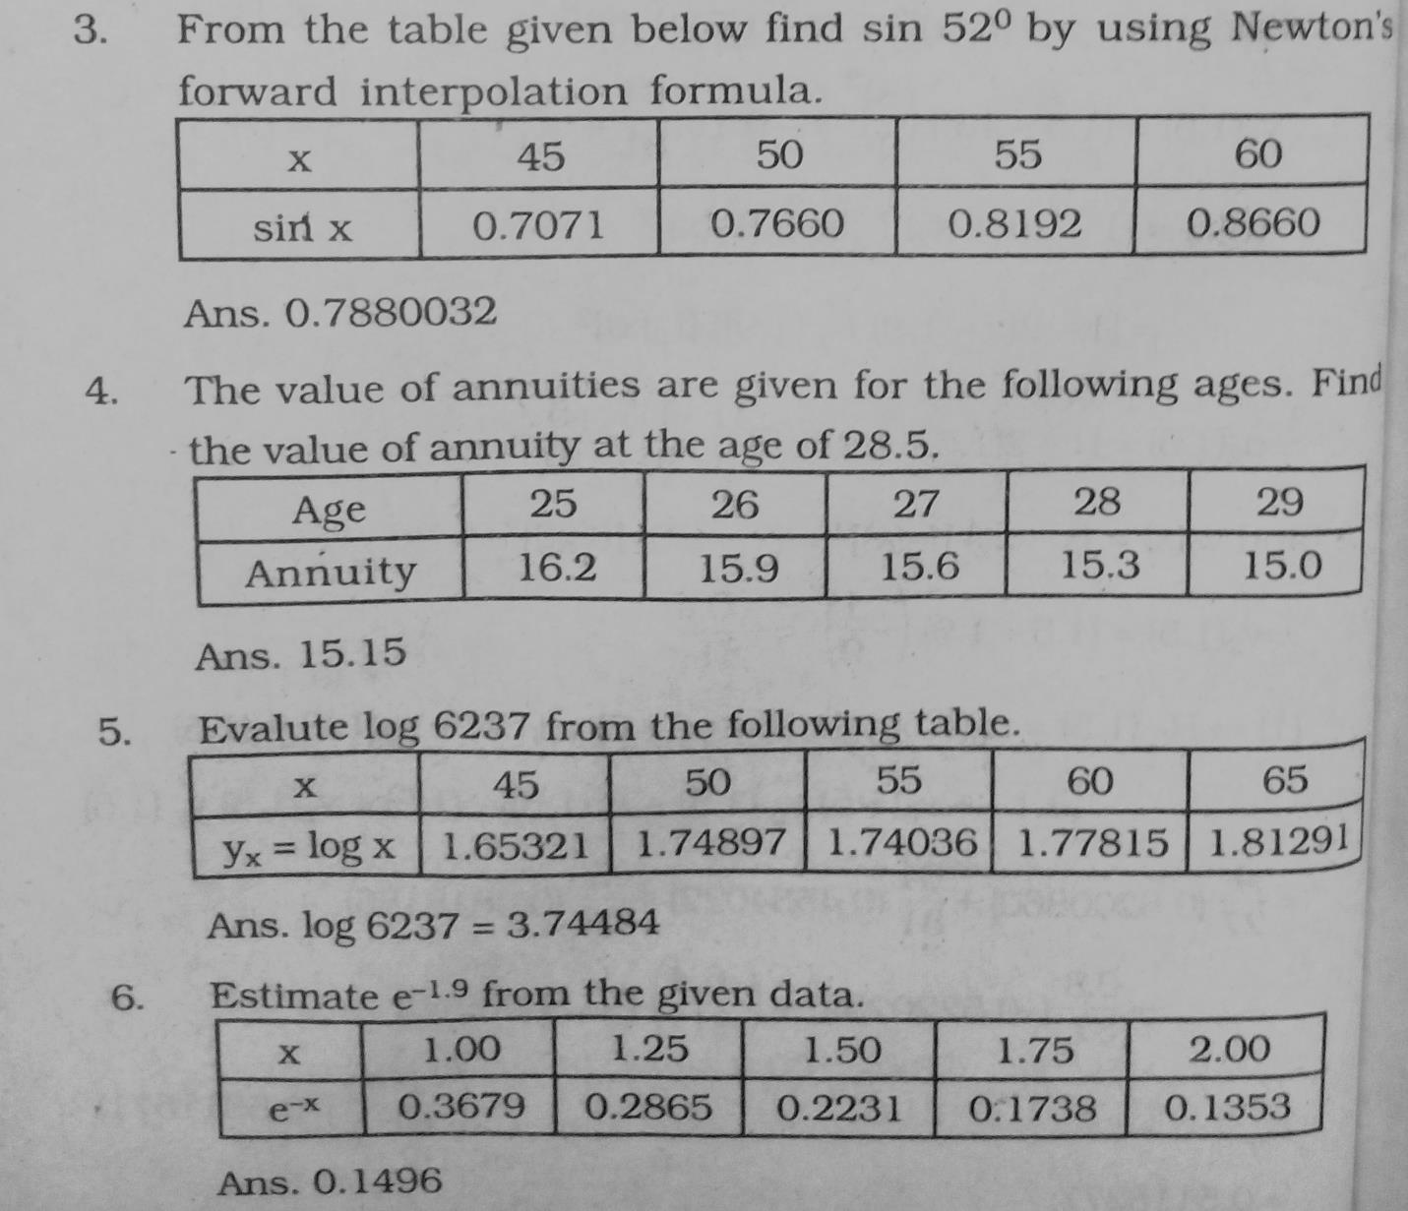

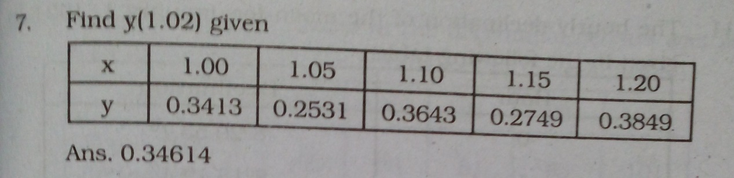

**8.**

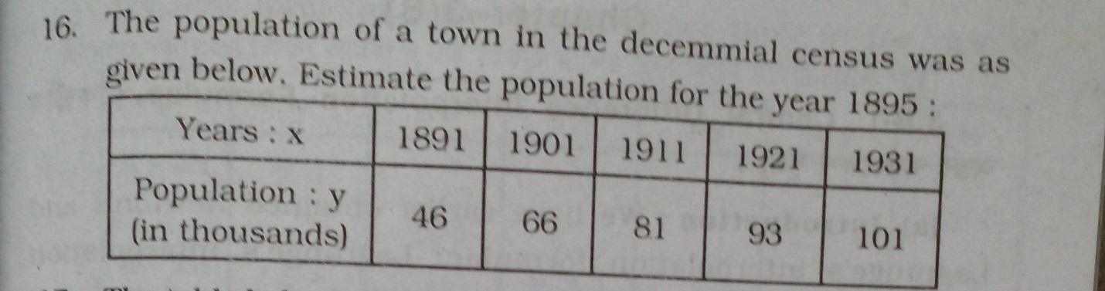

**Lagrange’s Interpolation Formula :**

**Statement:**

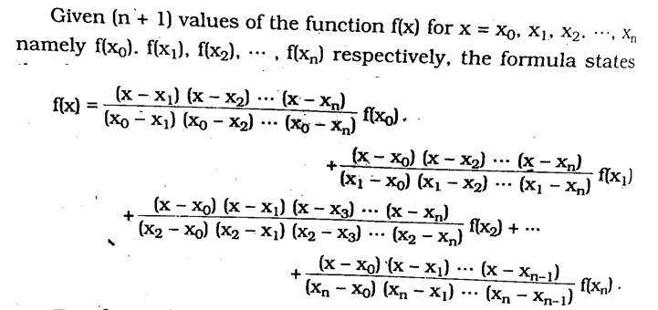

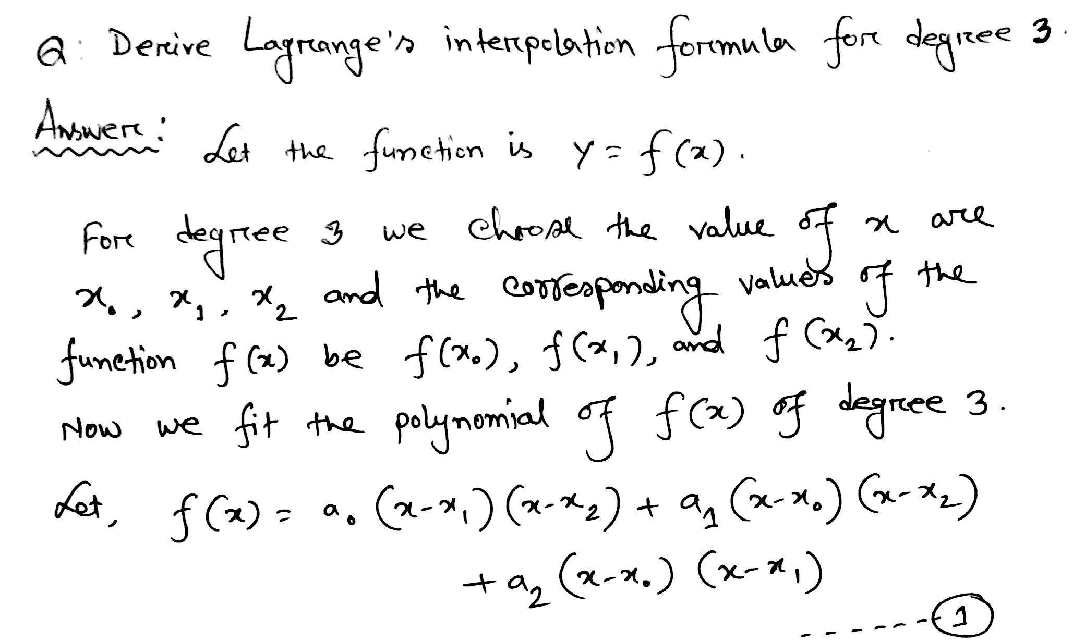

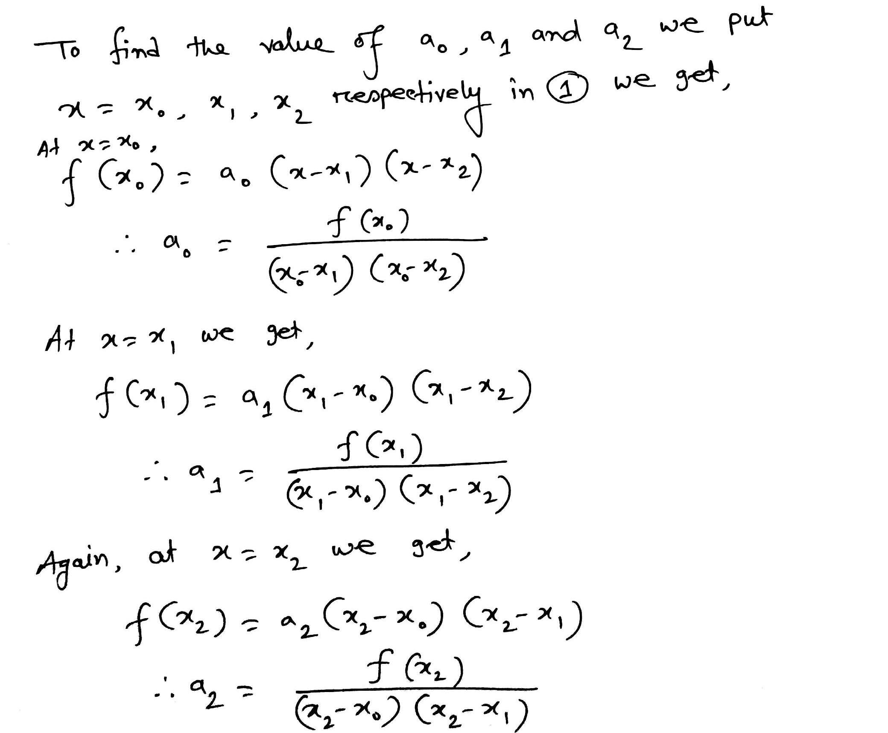

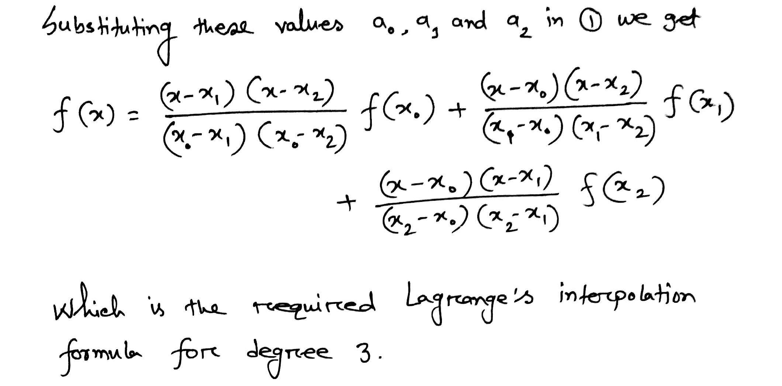

**Problem Solving:**

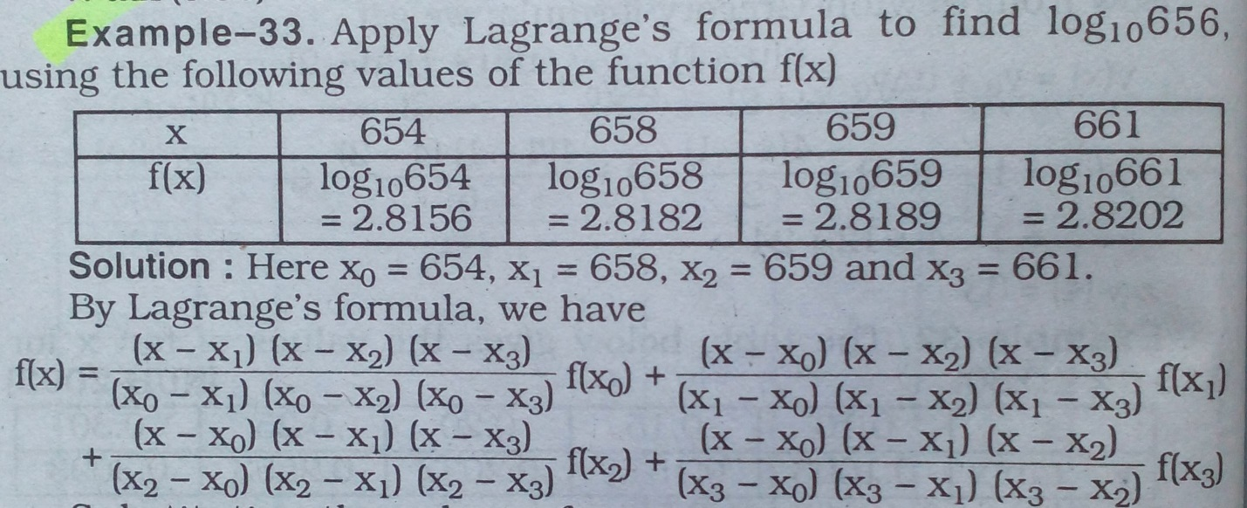

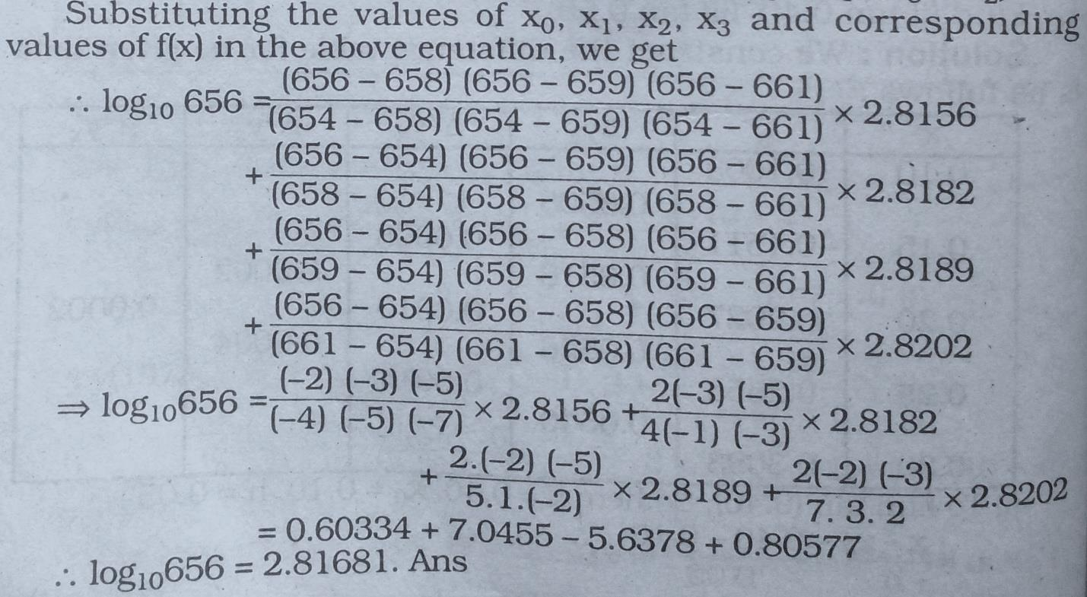

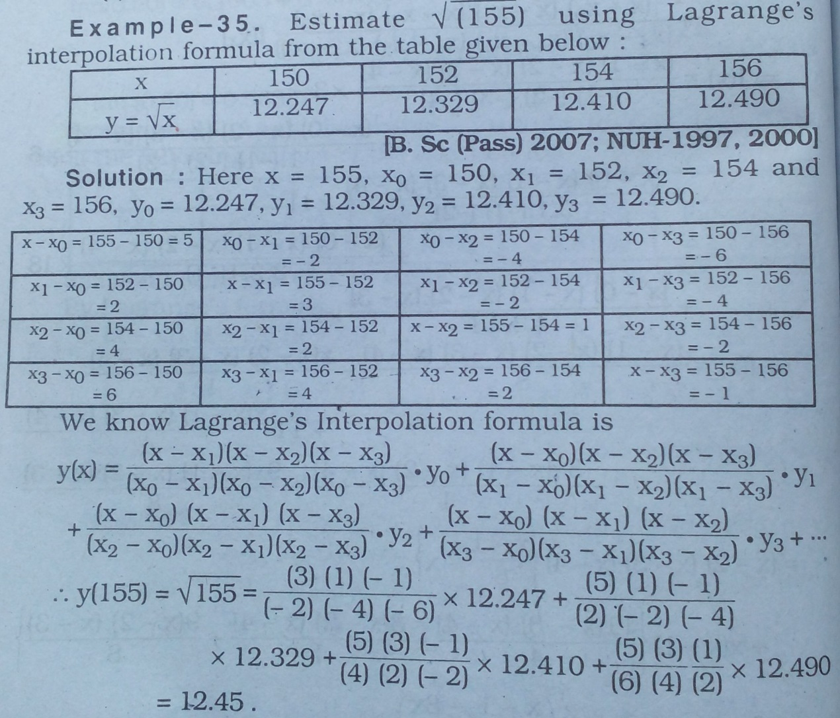

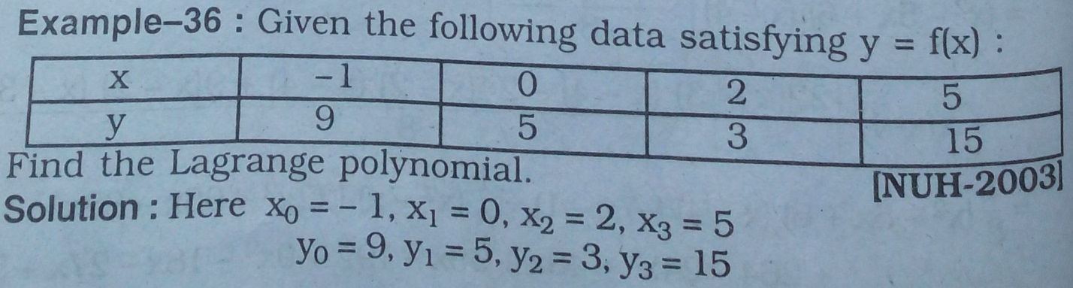

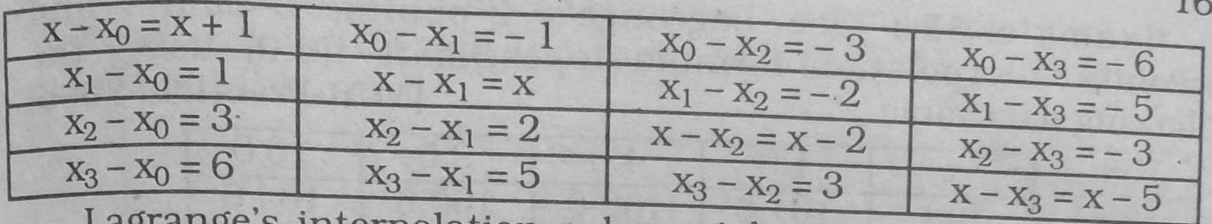

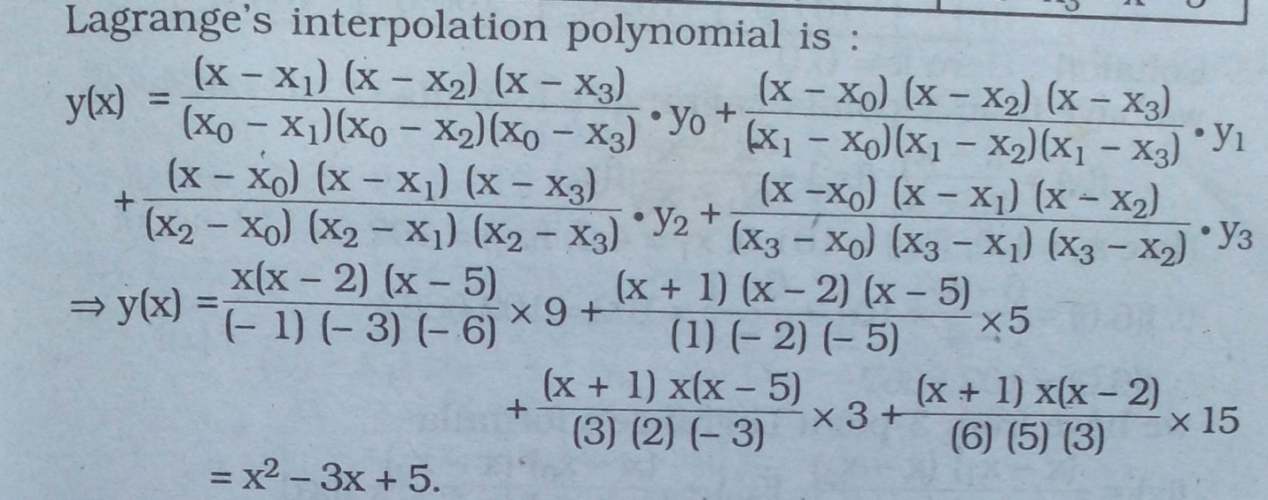

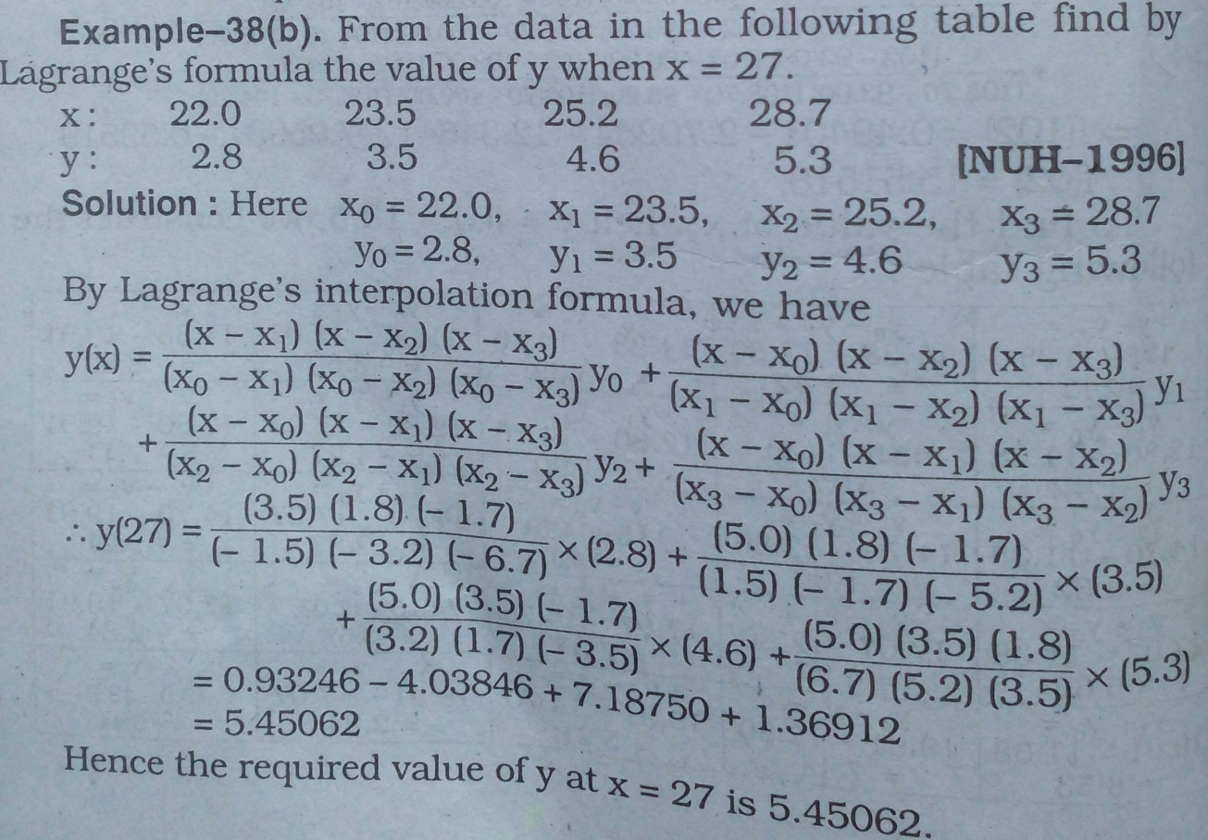

**For Practice:**

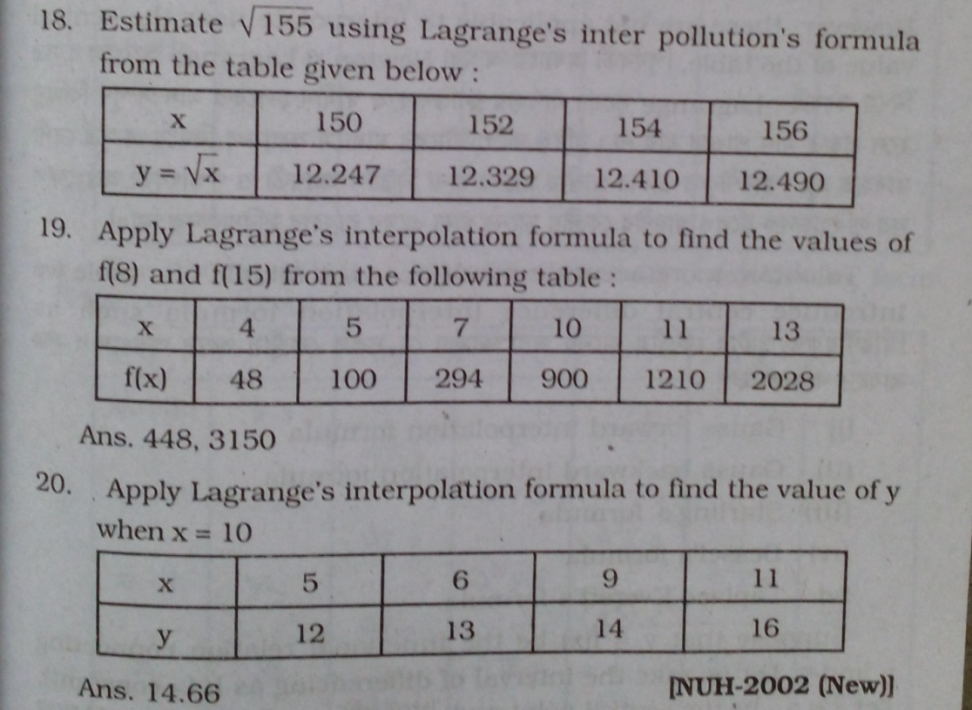

**Another Problem:**

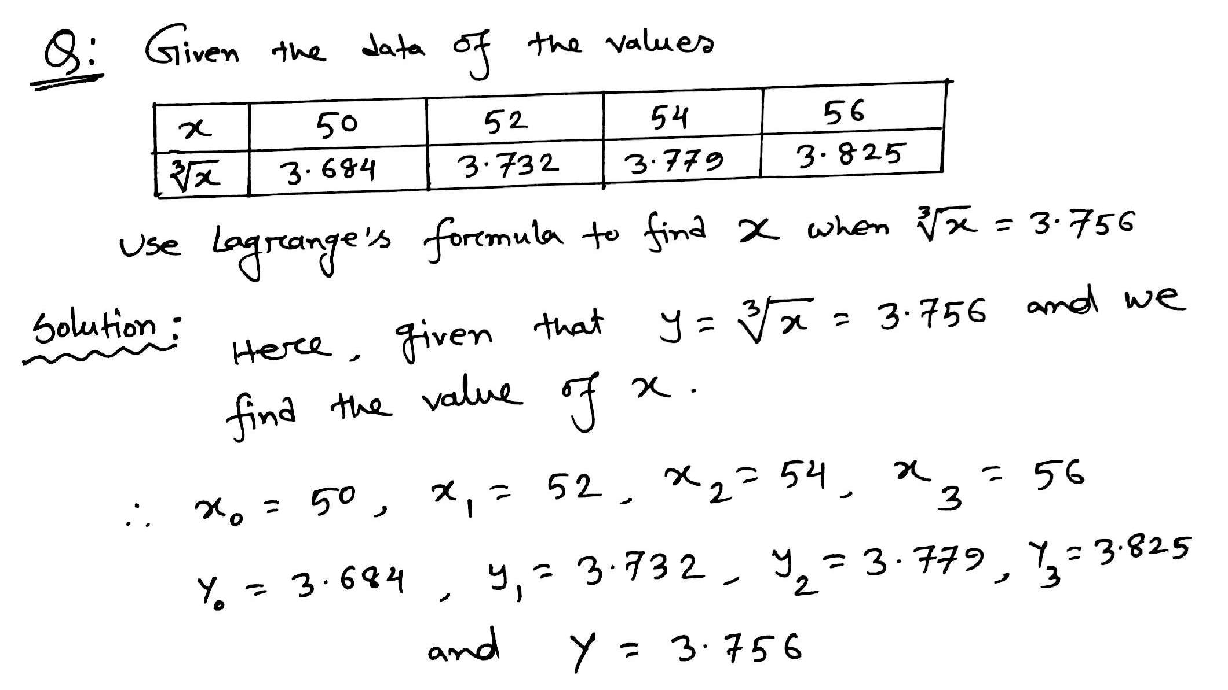

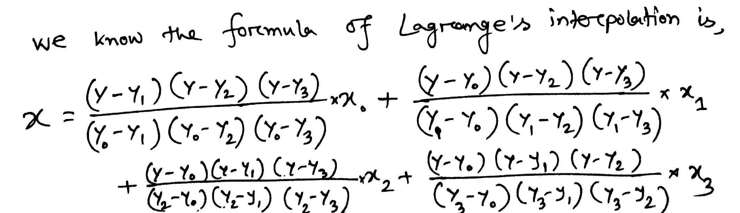

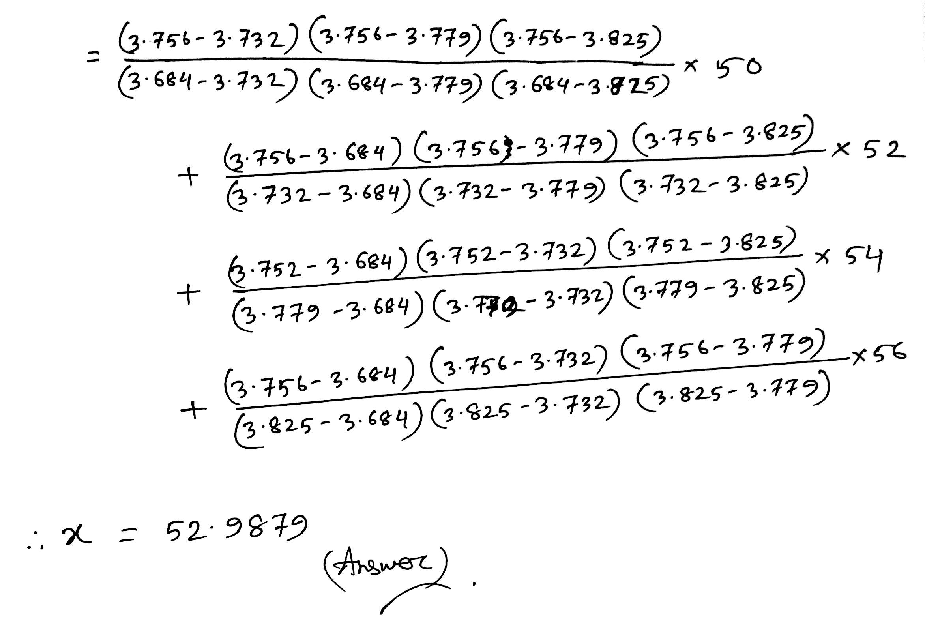

**For Practice:**

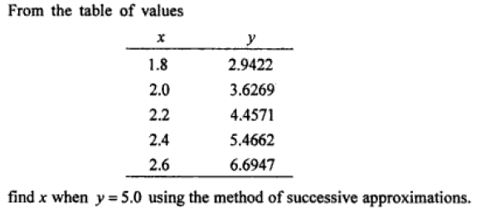

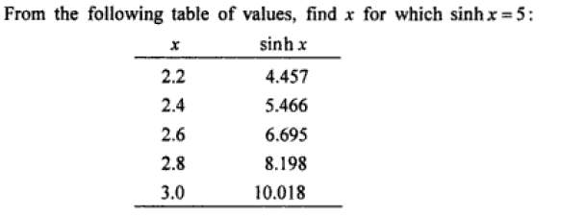

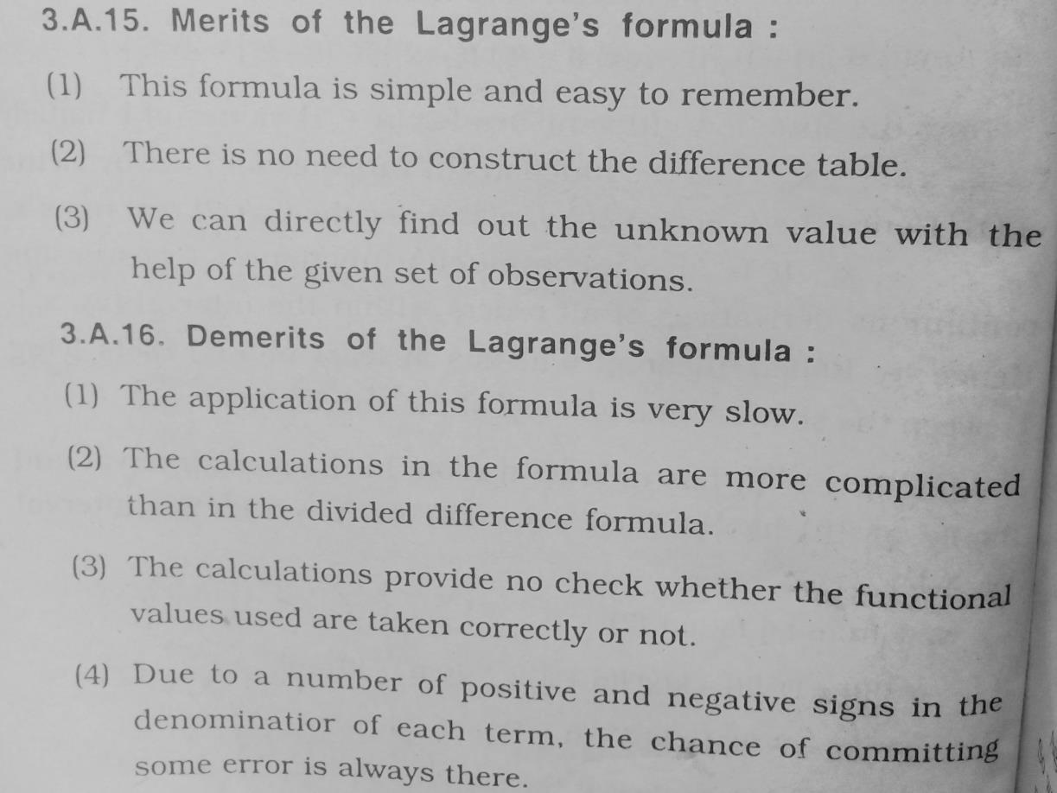

**Comparisons Between Lagrange and Newton Interpolation:**

The Lagrange and Newton interpolating formulas provide two different forms for an interpolating polynomial, even though the interpolating polynomial is unique.

* Lagrange method is numerically unstable but Newton's method is usually numerically stable and computationally efficient.
* Newton formula is much better for computation than the Lagrange formula.
* Lagrange form is most often used for deriving formulas for approximating derivatives and integrals
* Lagrange's form is more efficient then the Newton's formula when you have to interpolate several data sets on the same data points.